**Fun Done Planner App Report**

By Amanda Ebner and Syreen Banabilah

The Fun Done Planner App is an app for the user to be able to plan out the important aspects of their life in a password-protected environment. Within the app, the user will be able to create an account, plan out all of their most important tasks to be completed, and even rate the app. What the Fun Done Planner has that other planner apps do not is that it allows the user to separate tasks by whether they are special (only occurring once) or routine (occurring on a regular basis, whether that’s daily, weekly, or etc.) It also allows the user to protect their planned tasks within a password-protected account, so it won’t be viewable by just anyone. This also makes the app more effective for devices that are shared between multiple users, such as iPads or tablets that are shared within a family.

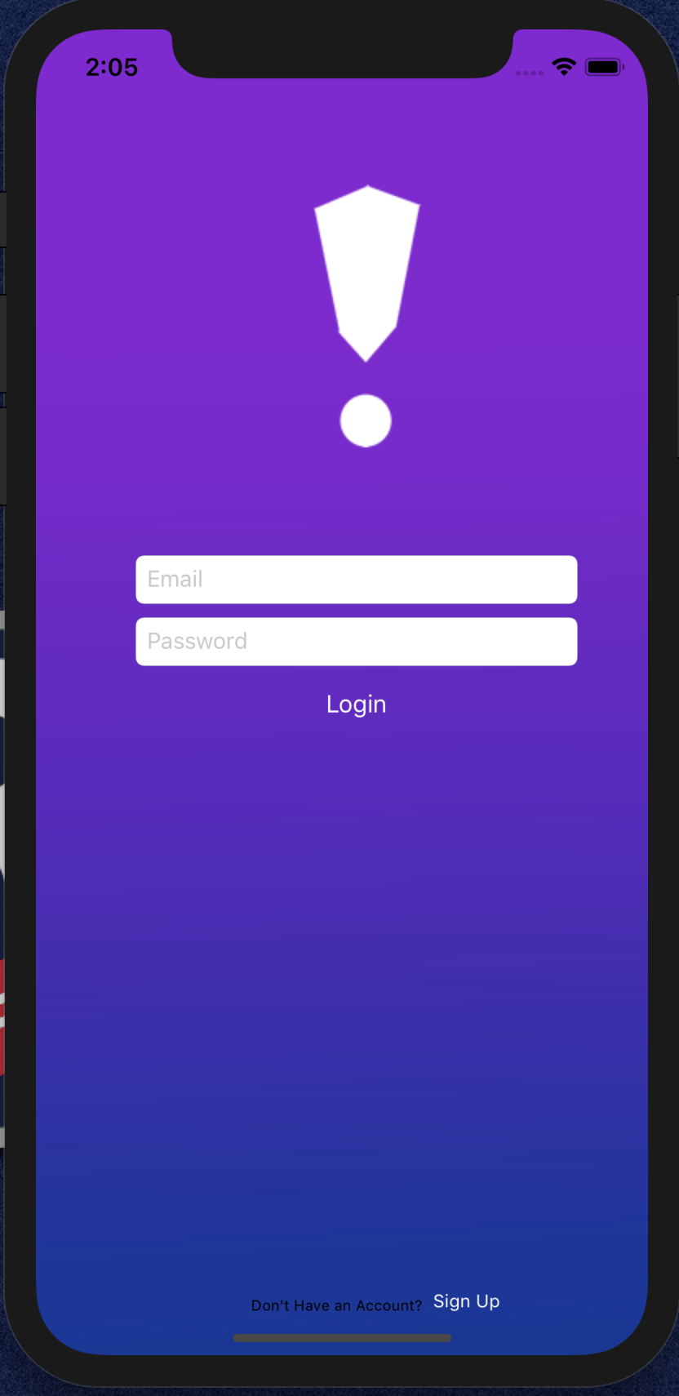

Once the user opens the app, the first scene is the login page. If the user has an account, he/she could log in to the app by entering the username and the password. However, if it is the first time for the user to use this app, he/she should move to the sign-up page by clicking on the sign-up button at the bottom of the scene.

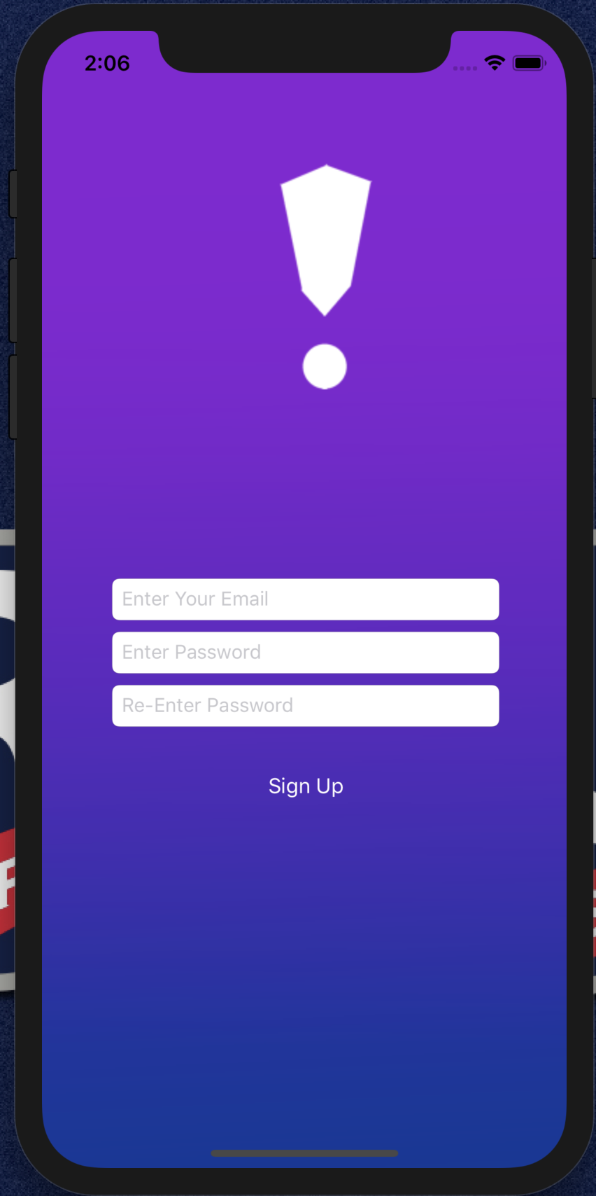

In the sign-up scene, the user should choose a unique username that is not used before, enter the password and confirm it, and finally click on the sign-up button. This will create the account and send the user back to the login page. After logging in, the app will take the user to the home screen.

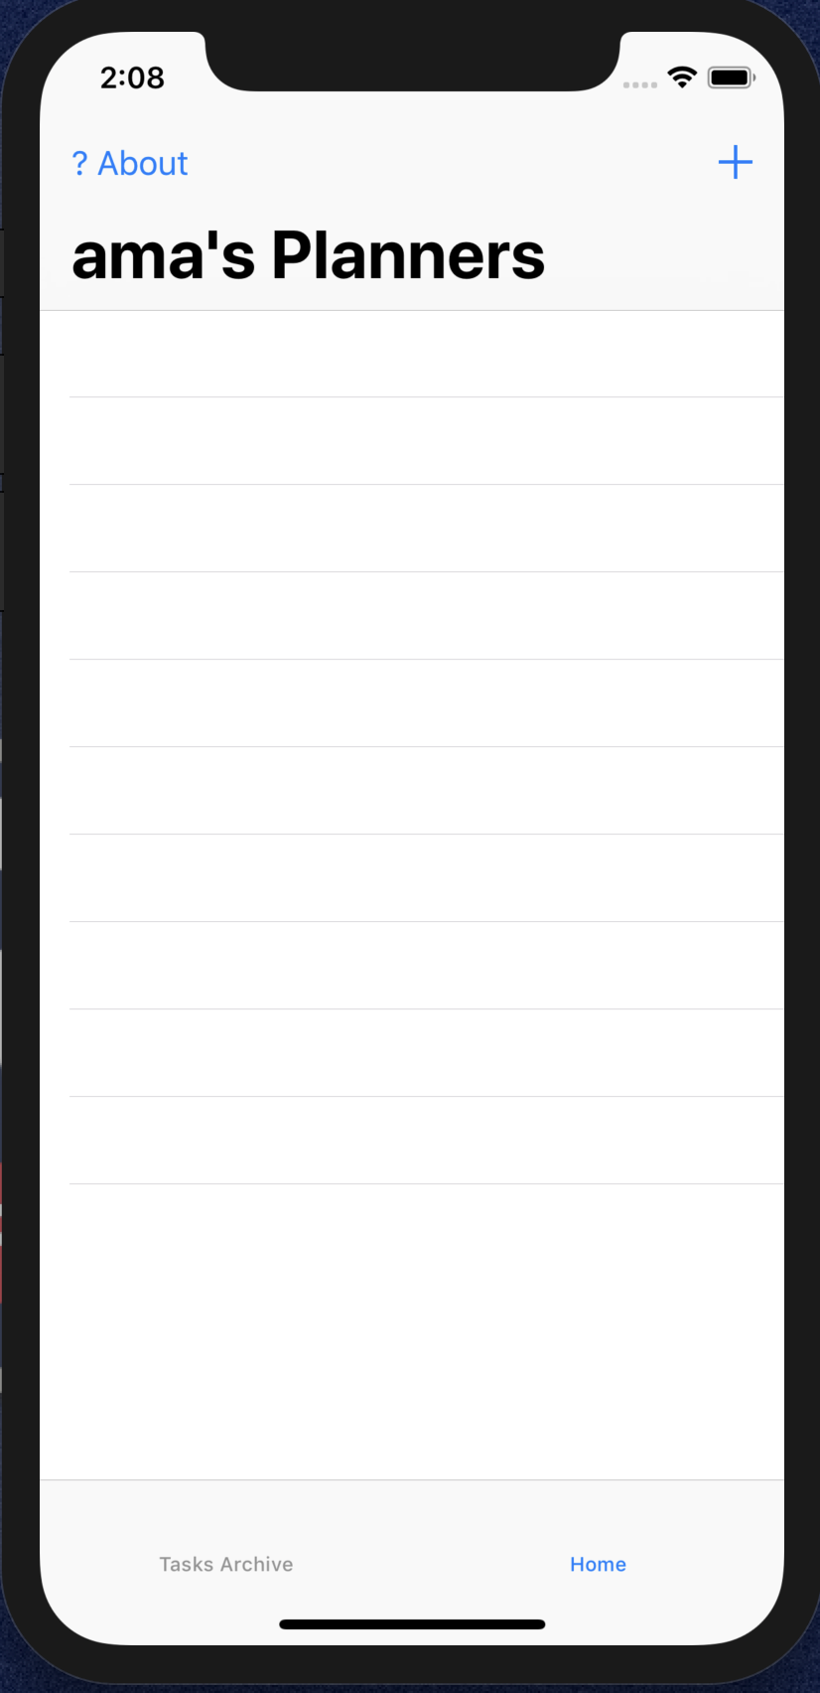

Once the user logs in successfully, the user will see the task of today. If the user completes a task, he/she can click on it and the checkmark will be added to the tableview cell. At the header, the home scene has a navigation bar which includes the name of the user, the add task button and about the button. (The name of the user will be exactly as was typed into the signup page.) There is a tab bar in the bottom to move and back between the home page and the tasks archive.

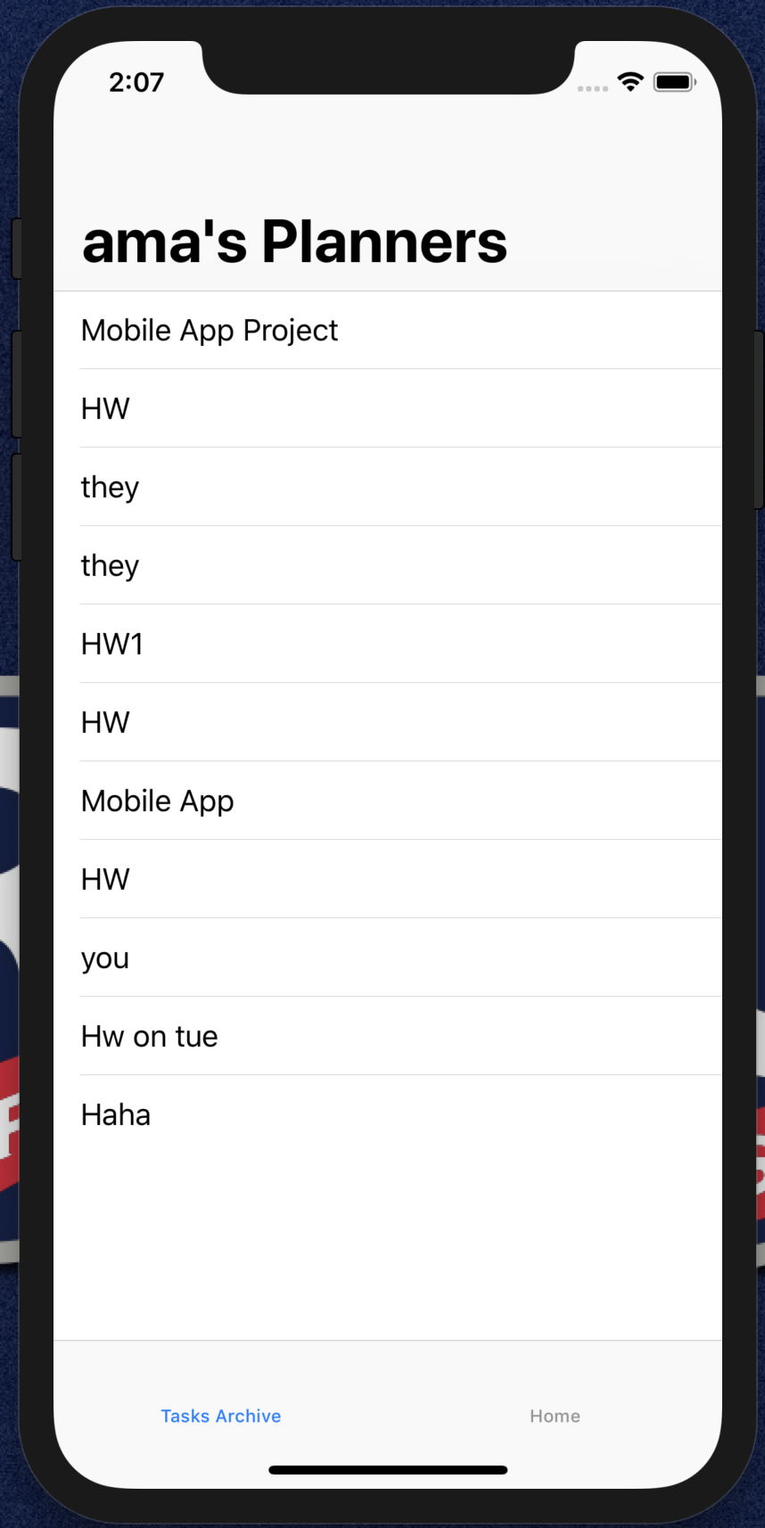

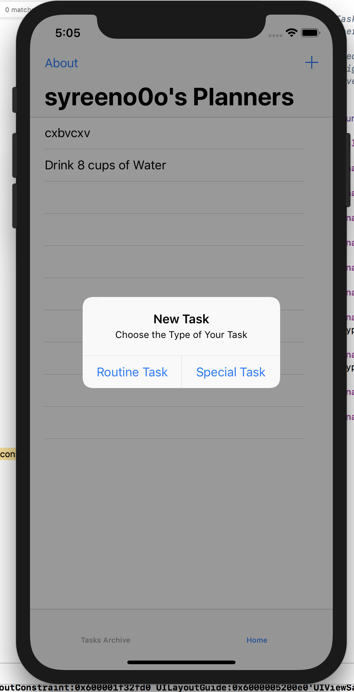

When the user clicks on the add button (a plus sign at the top right of the screen) an alert window will appear and ask the user to choose the type of the task. There are two types, the first one is the routine task such as cleaning your room each Monday. However, the second type is a special task, which will be displayed one time and once completed, will be deleted permanently. Whichever option the user chooses will take them to a new page to enter a task of that type.

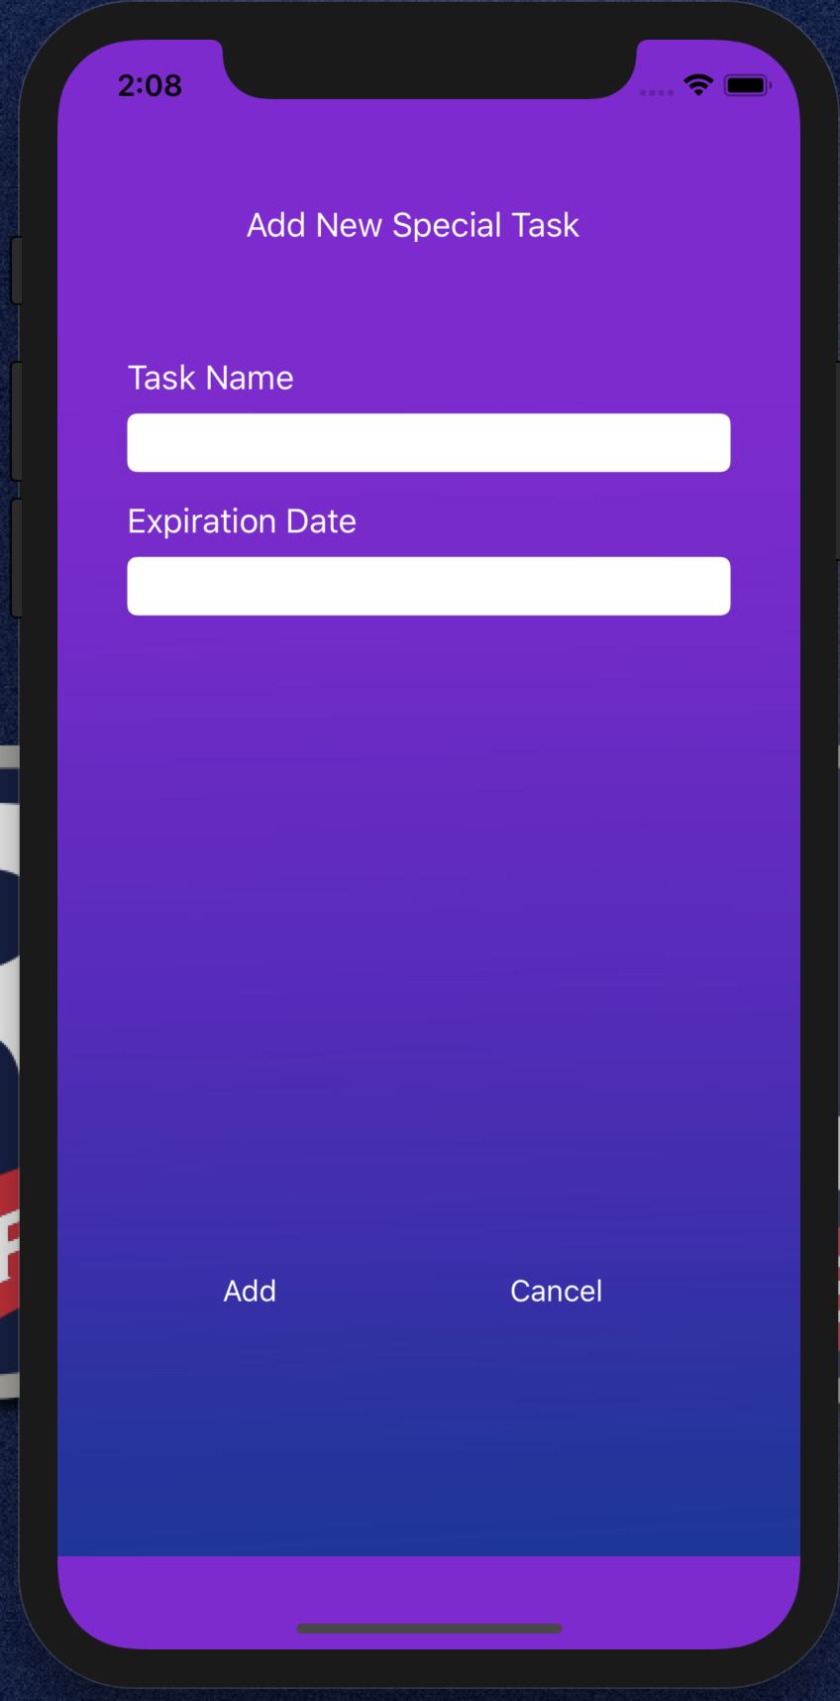

The Add Special Task page asks the user for two inputs: Task Name, and Expiration Date. The Task Name is a text field for the user to type in the name of their task, and the expiration date field is a date selector, automatically set to start on today’s date. Once the data is entered, the user can click on an add button at the bottom left of the screen to add the task to their planner, or at any point, they can click the cancel button on the bottom right of the screen to return to the planner without adding a task.

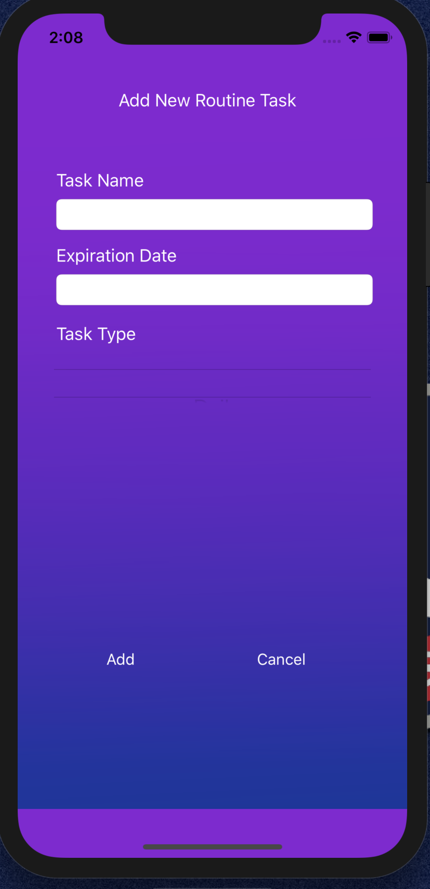

The Add New Routine Task page functions similarly to the Add New Special Task page with all of the same features but with one addition. On this page, the user can clarify what type of task(daily, monthly, etc.) the routine task is in a picker field beneath the expiration date.



Another scene is the tasks archive. This page can be accessed by using the tab bar that is visible on the Home page. (This bar can also be used to go from the Task Archive to the Home page.) In this page, all tasks will appear, and the user could delete a task if they see that the task is not useful anymore.

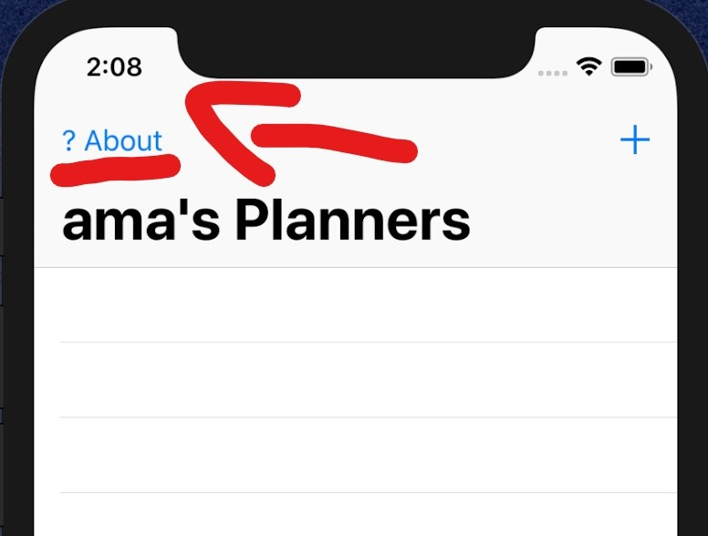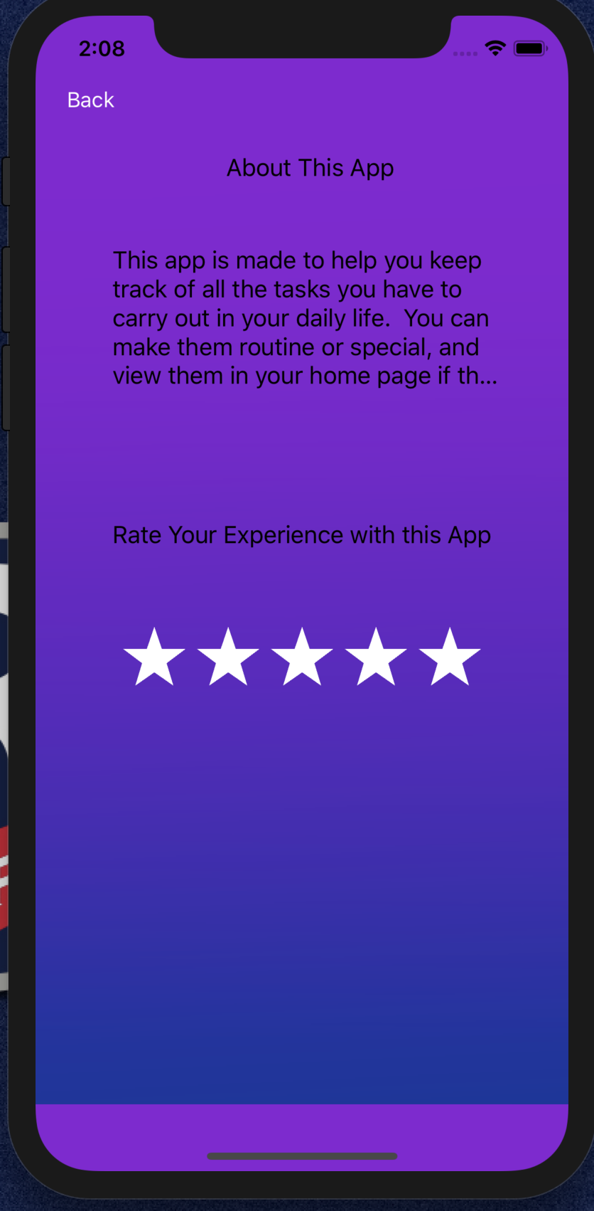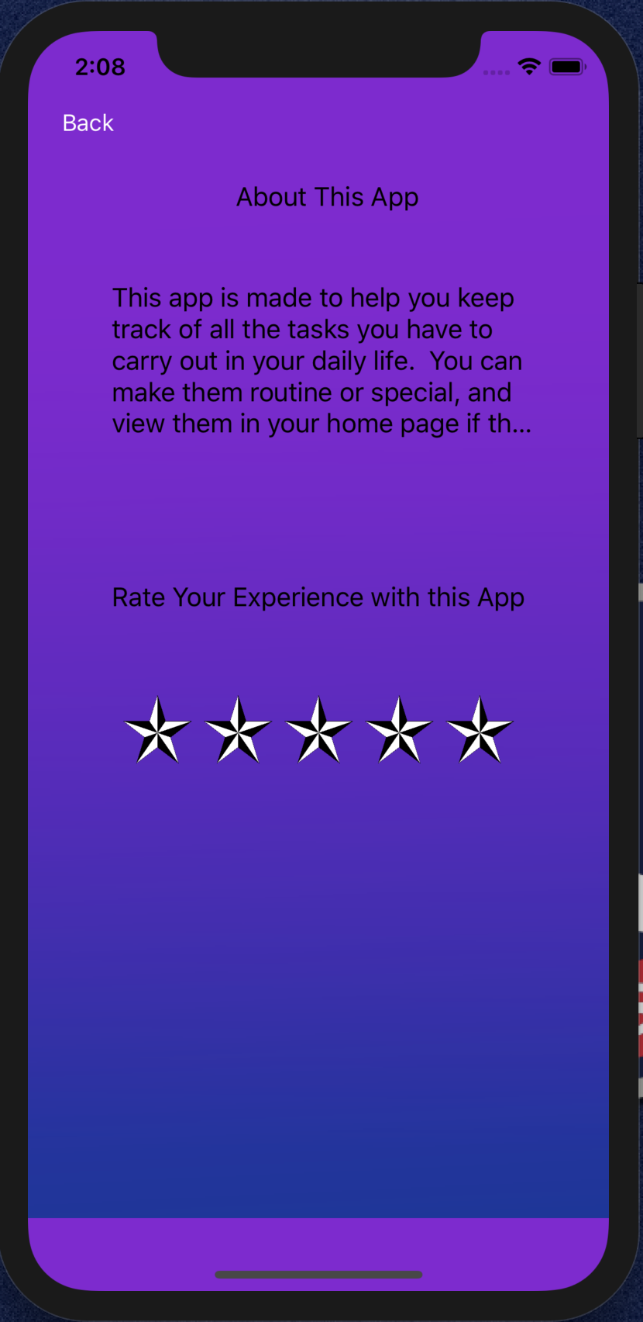

On the home screen, the user also has the option to click on a button with a question mark and About written on it to go to an about page. The About Page tells the user a little about the app and its purposes and gives the user a chance to rate the app out of five stars. (The picture above of the About Page on the left is of the page before the user has given their star rating. The picture to the right is the page after the user has given a five-star rating. Additionally, the stars turn blue when highlighted by the user.) Developing this rating system would not have been possible without the guidance of an online tutorial in the Apple Developer Reference Library, the “Implement a Custom Control” tutorial. This tutorial helped in the steps of creating five identical visuals that the user could click on to rank the app. After they are done rating the app and view the information about the app, the user can press the back button to return to the home screen.

**References:**

Start Developing iOS Apps (Swift): Implement a Custom Control. (2016, December 08). Retrieved April 18, 2019, from https://developer.apple.com/library/archive/referencelibrary/GettingStarted/DevelopiOSAppsSwift/ImplementingACustomControl.html